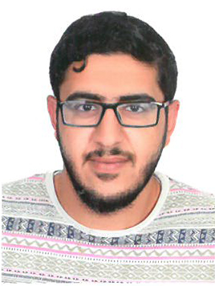

**PERSONAL DETAILS**

• Nationality: Bahraini

• ID No.: 971006806

• Social Status: Single

• Date of birth: 24 october 1997

• Interests: Traveling, Sports and surfing the net

**OBJECTIVE**

• I want to work to be a useful part of society and for the good of the institutions, I work in. To have better experience in life and be an independent person who people rely on. Hopefully, I earn different types of experience to grow more and be independent.

**EDUCATION**

* Arab open university 2019 (Business Adminstration)
* Bahrain polytechnic 2015-2018
* Isa bin ali secondary school(Commercial) 2012-2015

**WORK EXPERIENCS – FULL TIME**

* Al-dor company (data entry)-summer break 2012 2013 2014
* Shabab salmabad travel agency- February-Augast 2019

**ADDITIONAL SKILLS**

• Excellent command in Microsoft Office Word, Excel, Access, Power Point and browsing the Internet

• Languages: Arabic, English (writing & reading)

• Valuable teamwork & organization skills.

• Hard working, self-learner and highly self-motivated.

• Ability to work on own initiative and as part of a team.

• Ability to work under pressure in dynamic environment

• Confident and very ambitious person

**REFERENCES**

• Available upon request